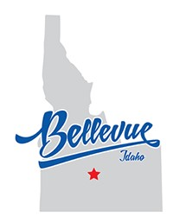
Common Council
City of Bellevue, Idaho
Thursday July 30, 2026
115 E Pine Street Bellevue, Idaho 83313
10am to 1pm
SPECIAL MEETING AGENDA
Agendas may be amended*

Join Teams Meeting: https://teams.microsoft.com/meet/282885101878467?p=RNG17qU6Hv6OMMIDGA
Meeting ID: 282 885 101 878 467
Passcode: uY6cV3Nm

Please Mute Your Call: Please turn off all cell phones except for emergency personnel.
Call to Order
Roll Call
- Notice of Agenda Compliance (Per Idaho code §74-204): Action Item
Finding that the SPECIAL meeting notice and agenda were posted in accordance with Idaho Code §74-204 within twenty-four (24) hours prior to the meeting at: the City of Bellevue City Hall, Post Office, and on the City’s website on July 28, 2026. Suggested Motion: The notice for the July 30 2026, meeting was completed in accordance with Idaho Code, Section §74-204.)
- Call For Conflict (as Outlined in Idaho Code §74-404): Action Item
- FY27 BUDGET WORK SESSION #5
- ADJOURNMENT: Action Item

