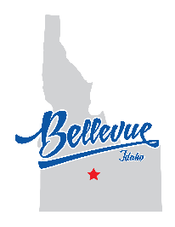
City of Bellevue Parks Committee
Vacancy Notice
The City of Bellevue is seeking dedicated individuals to serve on the Bellevue Parks Committee. Parks Committee volunteers are invaluable to the City and to the health of our park system. As a member of the Parks Committee, you would work with City Staff and the Common Council to advocate for our parks, plan for their future, and address concerns.
We strongly encourage you to apply!
Eligibility Requirements:
- Must be a resident of Bellevue or reside within a six (6) mile radius of the City.
- Be interested in the future of Bellevue’s public spaces, trails, natural resources, and recreation.
- It is helpful, but not required, to have experience in a related field. This could include landscape architecture, park maintenance, or recreation planning.
Responsibilities Include:
- Attending regular committee meetings
  - Meetings are currently held at 11:00 AM on the 3rd Wednesday of each month. If this time does not work for you, we still encourage you to apply; the meeting time and date can be changed.
- Working on action items from meetings, preparing reports and presentations, learning about public space issues.
- Collaborating with City Staff, the Common Council, and community members on planning projects for our parks.
How to Apply:
Interested individuals should submit a letter of interest outlining their qualifications and reasons for wanting to serve on the Committee. Please send your letter of interest to:
City of Bellevue, Attn: Amy Phelps, City Clerk
PO Box 825
Bellevue, Idaho 83313
OR:
aphelps@bellevueidaho.us

